## Project Report: Sales & Revenue Analysis for a Small Business

--Sayan Das

**Primary Goals**

1. **Extract** and **transform** the CSV data (customers, products, and sales) into a consistent, clean format.
2. **Load** the cleaned data into a **MySQL** database, organizing it into fact and dimension tables for easier analysis (star schema approach, but without a separate date dimension).
3. **Analyze** the data using **SQL** queries (top-selling products, low-performing categories, customer segmentation).
4. **Perform Predictive Modeling** using Python to:
   * **Forecast future sales trends** with **Prophet**.
   * **Predict Customer Lifetime Value (CLV)** using **BG/NBD** and **Gamma-Gamma** models from the **lifetimes** package.

### Assumptions and Tools

* **Python Environment**: I used Python 3.x with the following libraries:
  + **pandas**, **numpy** for data manipulation
  + **sqlalchemy** and **pymysql** for MySQL connectivity
  + **dateutil** for robust date parsing
  + **matplotlib** and **prophet** for forecasting
  + **lifetimes** for CLV modeling
* **MySQL**: Database named case5, user credentials set to root/12345 on localhost.
* **CSV Encodings**: Detected using the **chardet** library; determined to be ISO-8859-1.

### 1. Loading CSV Data into Pandas

I had four CSV datasets: - **AdventureWorks_Customers.csv**  
- **AdventureWorks_Products.csv**  
- **AdventureWorks_Sales_2015.csv**, **AdventureWorks_Sales_2016.csv**, **AdventureWorks_Sales_2017.csv**

I used the following Python code to detect file encodings and read the CSVs (excerpt):

import chardet  
  
# Detect file encoding  
with open('AdventureWorks_Customers.csv', 'rb') as f:  
 raw_data = f.read()  
result = chardet.detect(raw_data)  
print(result) # -> {'encoding': 'ISO-8859-1', 'confidence': 0.73, 'language': ''}  
  
# Read CSV files with the detected encoding  
customers_df = pd.read_csv("AdventureWorks_Customers.csv", encoding="ISO-8859-1")  
products_df = pd.read_csv("AdventureWorks_Products.csv", encoding="ISO-8859-1")  
sales_2015_df = pd.read_csv("AW Sales/AdventureWorks_Sales_2015.csv", encoding="ISO-8859-1")  
# etc.

This ensured I avoided UnicodeDecodeError issues.

### 2. Data Cleaning and Transformation in Python

I performed multiple data cleaning steps:

1. **Parsing BirthDate** (with slashes and dashes) using dateutil.parser.parse:

* def parse_birthdate(date_str):  
   try:  
   return parser.parse(date_str)  
   except:  
   return pd.NaT  
    
  customers_df['BirthDate'] = customers_df['BirthDate'].apply(parse_birthdate)

1. **Cleaning AnnualIncome** by removing symbols ($, commas) and converting to numeric:

* customers_df['AnnualIncome'] = (  
   customers_df['AnnualIncome']  
   .replace({r'\$': '', ',': ''}, regex=True)  
   .str.strip()  
  )  
  customers_df['AnnualIncome'] = pd.to_numeric(customers_df['AnnualIncome'], errors='coerce')

1. **Dropping Rows** with critical missing values:

* before_drop = len(customers_df)  
  customers_df.dropna(subset=['CustomerKey', 'BirthDate', 'AnnualIncome'], inplace=True)  
  after_drop = len(customers_df)  
  print(f"Dropped {before_drop - after_drop} rows from customers_df due to missing fields.")

1. **Transforming ProductSize** (S → 44, M → 48, etc.):

* size_mapping = {'S': 44, 'M': 48, 'L': 52, 'XL': 62}  
    
  def transform_size(x):  
   if isinstance(x, str):  
   x = x.strip()  
   if x in size_mapping:  
   return size_mapping[x]  
   else:  
   try:  
   return int(x)  
   except ValueError:  
   return np.nan  
   return x  
    
  products_df['ProductSize'] = products_df['ProductSize'].apply(transform_size)  
  products_df['ProductSize'] = pd.to_numeric(products_df['ProductSize'], errors='coerce')

1. **Combining Sales Data** from 2015, 2016, and 2017:

* sales_df = pd.concat([sales_2015_df, sales_2016_df, sales_2017_df], ignore_index=True)

1. **Converting OrderDate & StockDate** to datetime and dropping invalid rows:

* sales_df['OrderDate'] = pd.to_datetime(sales_df['OrderDate'], errors='coerce')  
  sales_df['StockDate'] = pd.to_datetime(sales_df['StockDate'], errors='coerce')

1. **Creating a CompositeKey** = OrderNumber + OrderLineItem for uniqueness:

* sales_df['CompositeKey'] = (  
   sales_df['OrderNumber'].astype(str) + "_" +  
   sales_df['OrderLineItem'].astype(str)  
  )

1. **Dropping Missing Values** in sales:

* before_drop = len(sales_df)  
  sales_df.dropna(subset=['OrderDate', 'ProductKey', 'CustomerKey', 'OrderQuantity'], inplace=True)  
  after_drop = len(sales_df)  
  print(f"Dropped {before_drop - after_drop} rows from sales_df due to missing fields.")

1. **Calculating Revenue** = OrderQuantity * ProductPrice (after merging ProductPrice from products_df).

### 3. Creating Fact and Dimension Tables

I opted for a star-schema style approach **without a separate date dimension**:

1. **dim_customer**: Contains each customer’s attributes (e.g., FirstName, LastName, BirthDate, etc.).
2. **dim_product**: Contains product attributes (e.g., ProductName, ProductSize, ProductPrice, etc.).
3. **fact_sales**: Contains the measures (OrderQuantity, Revenue) and foreign keys (CustomerKey, ProductKey), plus the date columns (OrderDate, StockDate).

#### Building Dimensions

dim_customer = customers_df.drop_duplicates(subset=['CustomerKey']).copy()  
dim_product = products_df.drop_duplicates(subset=['ProductKey']).copy()

#### Building the Fact Table

fact_sales = sales_df.merge(  
 dim_customer[['CustomerKey']], on='CustomerKey', how='left'  
).merge(  
 dim_product[['ProductKey']], on='ProductKey', how='left'  
)  
  
fact_sales = fact_sales[[  
 'CompositeKey',  
 'CustomerKey',  
 'ProductKey',  
 'OrderDate',  
 'StockDate',  
 'OrderQuantity',  
 'ProductPrice',  
 'Revenue'  
]]

### 4. Loading Data to MySQL

I used **SQLAlchemy** to connect and write the tables to MySQL:

username = 'root'  
password = '12345'  
host = 'localhost'  
port = '3306'  
database = 'case5'  
engine = create_engine(f'mysql+pymysql://{username}:{password}@{host}:{port}/{database}')  
  
dim_customer.to_sql('dim_customer', engine, index=False, if_exists='replace')  
dim_product.to_sql('dim_product', engine, index=False, if_exists='replace')  
fact_sales.to_sql('fact_sales', engine, index=False, if_exists='replace')  
  
print("Data loaded to MySQL successfully!")

At this point, I had **three tables** in MySQL:  
- **dim_customer**  
- **dim_product**  
- **fact_sales**

### 5. SQL Queries for Analysis

**Schema**

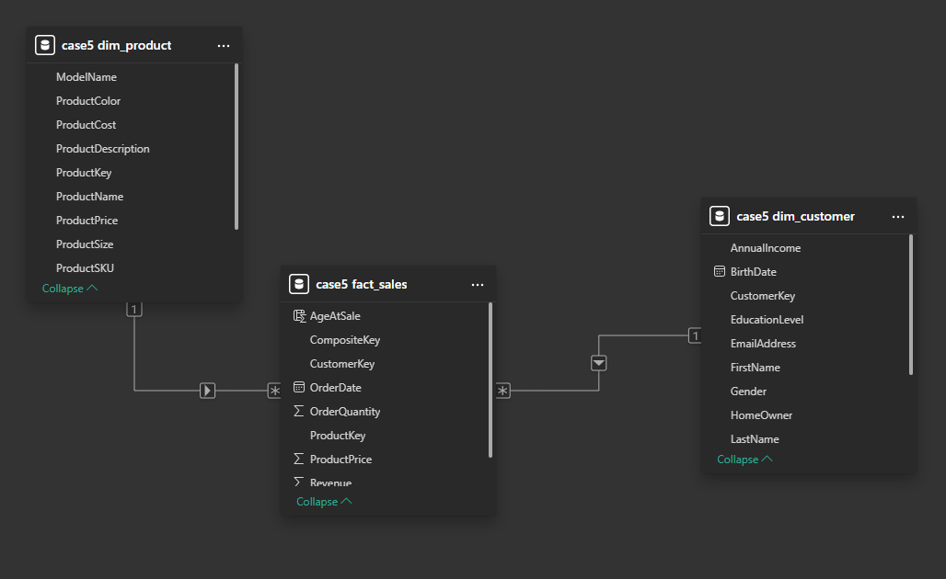

**Sales trends across months**

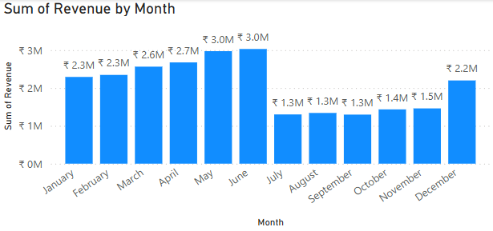

**Best-performing product categories**  
-- Top 10 products by total revenue  
SELECT   
 p.ProductKey,  
 p.ProductName,  
 SUM(f.Revenue) AS TotalRevenue  
FROM fact_sales AS f  
JOIN dim_product AS p   
 ON f.ProductKey = p.ProductKey  
GROUP BY p.ProductKey, p.ProductName  
ORDER BY TotalRevenue DESC  
LIMIT 10;

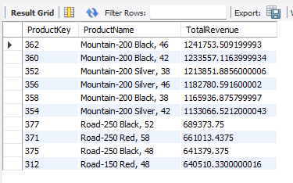  
  
-- Bottom 5 product subcategories by total revenue  
SELECT   
 p.ProductSubcategoryKey,  
 SUM(f.Revenue) AS SubcategoryRevenue  
FROM fact_sales AS f  
JOIN dim_product AS p   
 ON f.ProductKey = p.ProductKey  
GROUP BY p.ProductSubcategoryKey  
ORDER BY SubcategoryRevenue ASC  
LIMIT 5;

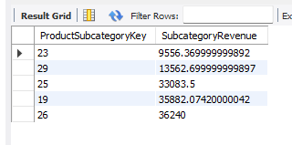  
  
**Revenue impact of discounts and promotions:**

Cannot be generated as no discount or promotion data is given

**Customer purchase patterns and segmentation**

-- Customer Segmentation (High-Value, Frequent, Occasional)  
WITH customer_summary AS (  
 SELECT   
 c.CustomerKey,  
 COUNT(DISTINCT f.CompositeKey) AS total_orders,  
 SUM(f.Revenue) AS total_spent  
 FROM fact_sales AS f  
 JOIN dim_customer AS c   
 ON f.CustomerKey = c.CustomerKey  
 GROUP BY c.CustomerKey  
)  
SELECT   
 CustomerKey,  
 total_orders,  
 total_spent,  
 CASE  
 WHEN total_spent >= 1000 THEN 'High-Value'  
 WHEN total_orders >= 10 THEN 'Frequent Buyer'  
 WHEN total_orders BETWEEN 2 AND 9 THEN 'Occasional Buyer'  
 ELSE 'Rare Buyer'  
 END AS Segment  
FROM customer_summary  
ORDER BY total_spent DESC;

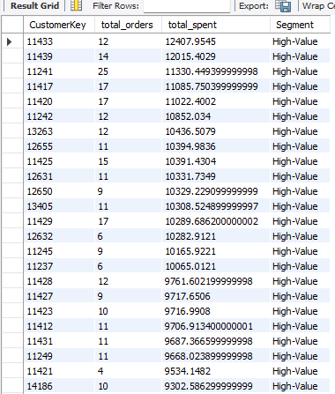

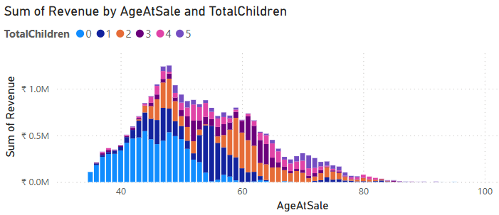

### 6. Predictive Modeling

#### 6.1 Forecast Future Sales with Prophet

I aggregated daily revenue from fact_sales and fit a **Prophet** model:

import matplotlib.pyplot as plt  
from prophet import Prophet  
  
sales_trends = fact_sales.groupby('OrderDate')['Revenue'].sum().reset_index()  
sales_trends.columns = ['ds', 'y'] # Prophet requires ds, y  
  
model = Prophet()  
model.fit(sales_trends)  
  
future = model.make_future_dataframe(periods=90)  
forecast = model.predict(future)  
  
model.plot(forecast)  
plt.title("Forecast of Future Sales Revenue")  
plt.xlabel("Date")  
plt.ylabel("Revenue")  
plt.show()

Prophet produced a forecast line (blue) and confidence intervals (shaded region) for the next 90 days. This helps me anticipate **future revenue trends** and manage inventory.

#### 6.2 Predict Customer Lifetime Value (CLV)

Using the **lifetimes** library, I applied the **BG/NBD** and **Gamma-Gamma** models:

from lifetimes.utils import summary_data_from_transaction_data  
from lifetimes import BetaGeoFitter, GammaGammaFitter  
  
summary = summary_data_from_transaction_data(  
 transactions=fact_sales,  
 customer_id_col='CustomerKey',  
 datetime_col='OrderDate',  
 monetary_value_col='Revenue',  
 observation_period_end=fact_sales['OrderDate'].max()  
)  
  
# Filter out customers with frequency 0  
summary_filtered = summary[summary['frequency'] > 0]  
  
# BG/NBD model  
bgf = BetaGeoFitter(penalizer_coef=0.0)  
bgf.fit(summary_filtered['frequency'], summary_filtered['recency'], summary_filtered['T'])  
  
summary_filtered['predicted_purchases_90'] = bgf.\  
 conditional_expected_number_of_purchases_up_to_time(  
 90,  
 summary_filtered['frequency'],  
 summary_filtered['recency'],  
 summary_filtered['T']  
 )  
  
# Gamma-Gamma for monetary value  
ggf = GammaGammaFitter(penalizer_coef=0.0)  
ggf.fit(summary_filtered['frequency'], summary_filtered['monetary_value'])  
  
summary_filtered['expected_average_profit'] = ggf.\  
 conditional_expected_average_profit(  
 summary_filtered['frequency'],  
 summary_filtered['monetary_value']  
 )  
  
# CLV over 12 months  
summary_filtered['CLV'] = ggf.customer_lifetime_value(  
 bgf,  
 summary_filtered['frequency'],  
 summary_filtered['recency'],  
 summary_filtered['T'],  
 summary_filtered['monetary_value'],  
 time=12,  
 freq='D',  
 discount_rate=0.01  
)  
  
print(summary_filtered[['predicted_purchases_90', 'expected_average_profit', 'CLV']].head())

**Interpretation**: - **predicted_purchases_90**: The expected number of purchases in the next 90 days.  
- **expected_average_profit**: The average revenue (profit) per transaction.  
- **CLV**: The total present value of expected future revenue from each customer over a 12-month horizon.  
  
**Output:**

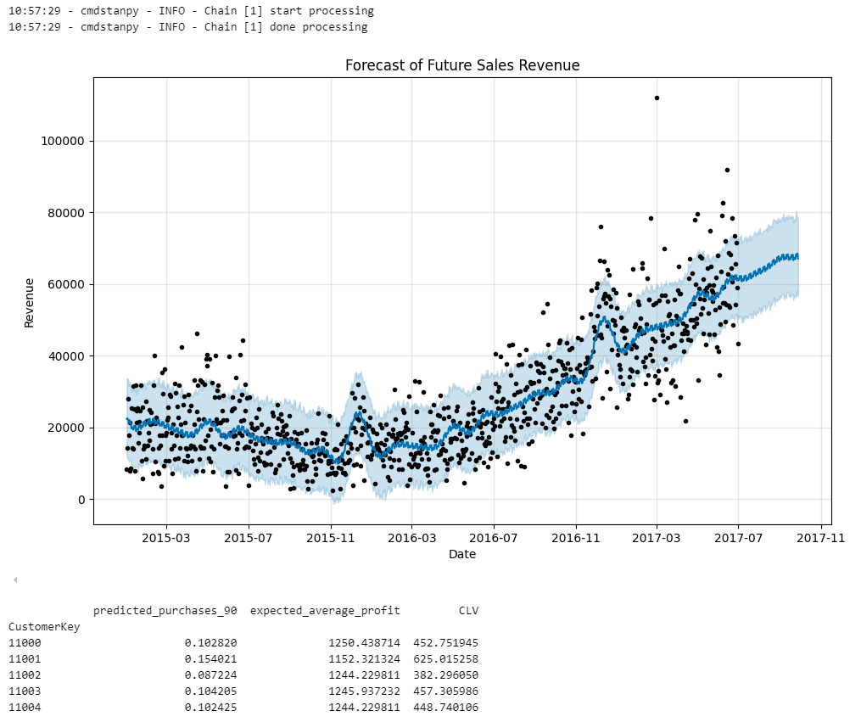

### 7. PowerBi Report

**DAX –**

AgeAtSale =

DATEDIFF(

    RELATED('case5 dim_customer'[BirthDate]),

    'case5 fact_sales'[OrderDate],

    YEAR

)

**Renames:**

M -> Male, F -> Female, S->Single, M-> Married, etc.

### 

### Conclusion

**Education Level**: Customers with higher education (Bachelor’s or Graduate Degree) tend to generate more revenue than other groups.

**Occupation**: Occupations like “Professional” rank at the top of total revenue.

**AgeAtSale & TotalChildren**: A substantial portion of revenue comes from customers in their **40s–50s** who have **0 children**.

**High-Revenue Subcategories**: One or two product subcategories drive the majority of revenue, often with a balanced price–demand ratio.

**Peak Months**: Revenue increase steadity till June and then drops abruptly from June to July.

**Year-over-Year Growth**: Revenue increased from 2015 to 2016 but stayed almost same from 2016 - 2017